Ex.no:5 | DATA VISUALIZATION USING MATPLOTLIB

Aim:
To visualize diabetic patient data and analyze different patient features and distributions using line charts, bar charts, pie charts, histograms, scatter plots, box plots, and multiple line charts using Matplotlib.

ALGORITHM 1: LINE CHART
Objective: To visualize the average hospital stay across different age groups.
Steps
- Select the age and time_in_hospital columns.
- Calculate the average hospital stay for each age group.
- Arrange the age groups in order.
- Plot the average hospital stay using a line chart.
- Add title and axis labels.
- Display the graph.
Interpretation
The line chart shows how the average duration of hospital stay varies across different age groups.
Code:
age_stay = df.groupby("age")["time_in_hospital"].mean()
plt.figure(figsize=(10,5))
plt.plot(age_stay.index, age_stay.values, marker='o')
plt.title("Average Hospital Stay by Age Group")
plt.xlabel("Age Group")
plt.ylabel("Average Hospital Stay")
plt.xticks(rotation=45)
plt.grid(True)
plt.show()

ALGORITHM 2: BAR CHART
Objective: To compare the average hospital stay for different genders.
Steps
- Select the gender and time_in_hospital columns.
- Calculate the average hospital stay for each gender.
- Create a bar chart using the gender groups and their average hospital stay.
- Add title and axis labels.
- Display the chart.
Interpretation
The bar chart provides a comparison of the average hospital stay among different gender groups.
Code:
gender_stay = df.groupby("gender")["time_in_hospital"].mean()
plt.figure(figsize=(7,5))
plt.bar(gender_stay.index, gender_stay.values)
plt.title("Average Hospital Stay by Gender")
plt.xlabel("Gender")
plt.ylabel("Average Hospital Stay")
plt.show()

ALGORITHM 3: PIE CHART
Objective: To visualize the distribution of diabetic patients based on race.
Steps
- Select the race column.
- Count the occurrences of each race category.
- Calculate their proportions.
- Create a pie chart.
- Display percentage labels.
- Add a suitable title.
Interpretation
The pie chart shows the percentage contribution of each race category to the total number of diabetic patient encounters.
Code:
race_count = df["race"].value_counts()
plt.figure(figsize=(8,6))
plt.pie(
race_count.values,
labels=race_count.index,
autopct='%1.1f%%'
)
plt.title("Patient Distribution by Race")
plt.show()
ALGORITHM 4: HISTOGRAM
Objective: To visualize the distribution of time spent by patients in the hospital.
Steps
- Select the time_in_hospital column.
- Divide the hospital stay values into intervals or bins.
- Create a histogram using Matplotlib.
- Add title and axis labels.
- Display the histogram.
Interpretation
The histogram shows the frequency distribution of the number of days patients spend in the hospital and helps understand the common duration of hospital stays.
Code:
plt.figure(figsize=(8,5))
plt.hist(df["time_in_hospital"], bins=20)
plt.title("Distribution of Hospital Stay")
plt.xlabel("Time in Hospital (Days)")
plt.ylabel("Frequency")
plt.show()

ALGORITHM 5: SCATTER PLOT
Objective: To analyze the relationship between the number of lab procedures and the number of medications.
Steps
- Select num_lab_procedures as the X-axis variable.
- Select num_medications as the Y-axis variable.
- Plot the observations using a scatter plot.
- Add title and axis labels.
- Display the graph.
Interpretation
The scatter plot helps identify the relationship between the number of laboratory procedures performed and the number of medications administered to patients.
Code:
plt.figure(figsize=(8,5))
plt.scatter(
df["num_lab_procedures"],
df["num_medications"],
alpha=0.3
)
plt.title("Lab Procedures vs Medications")
plt.xlabel("Number of Lab Procedures")
plt.ylabel("Number of Medications")
plt.show()

ALGORITHM 6: BOX PLOT
Objective: To visualize the distribution and identify possible outliers in the number of lab procedures.
Steps
- Select the num_lab_procedures column.
- Remove missing values if present.
- Create a box plot using Matplotlib.
- Add a suitable title and axis label.
- Display the plot.
Interpretation
The box plot shows the central distribution of laboratory procedures and helps identify unusually high or low values.
Code:
plt.figure(figsize=(7,5))
plt.boxplot(df["num_lab_procedures"].dropna())
plt.title("Lab Procedures Box Plot")
plt.ylabel("Number of Lab Procedures")
plt.show()

ALGORITHM 7: MULTIPLE LINE CHART
Objective: To compare the average number of lab procedures and medications across different age groups.
Steps
- Calculate the average number of lab procedures for each age group.
- Calculate the average number of medications for each age group.
- Arrange both datasets according to the age groups.
- Plot the average lab procedures using a line chart.
- Plot the average medications using another line on the same graph.
- Add labels and a legend.
- Display the graph.
Interpretation
The multiple line chart allows comparison of average laboratory procedures and medications across different age groups and helps identify variations between the two measures.
Code:
age_analysis = df.groupby("age")[
["num_lab_procedures", "num_medications"]
].mean()
plt.figure(figsize=(10,5))
plt.plot(
age_analysis.index,
age_analysis["num_lab_procedures"],
marker='o',
label="Average Lab Procedures"
)
plt.plot(
age_analysis.index,
age_analysis["num_medications"],
marker='o',
label="Average Medications"
)
plt.title("Average Lab Procedures and Medications by Age Group")
plt.xlabel("Age Group")
plt.ylabel("Average Value")
plt.xticks(rotation=45)
plt.legend()
plt.grid(True)
plt.show()
Output: 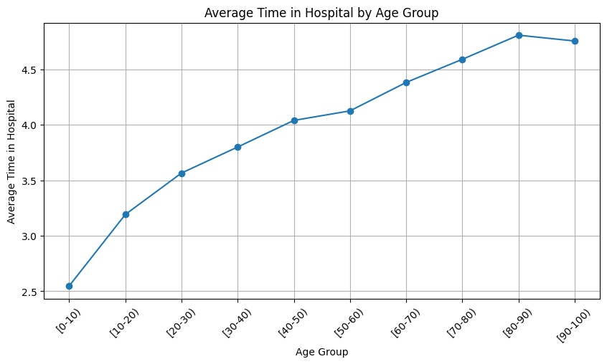

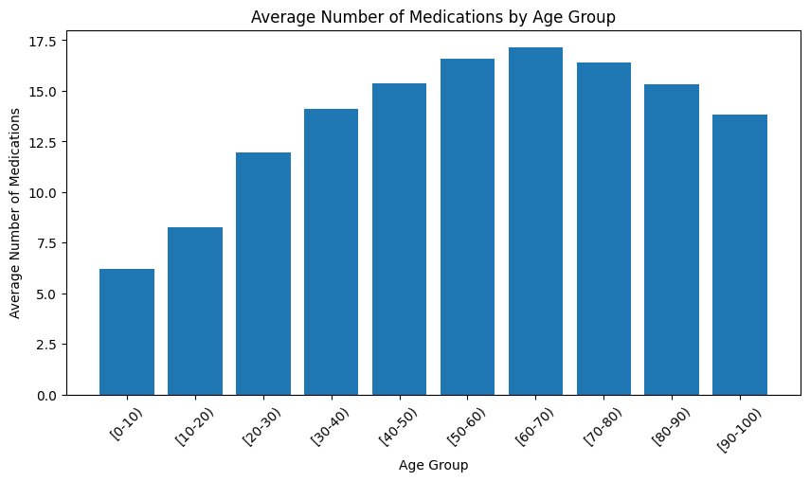
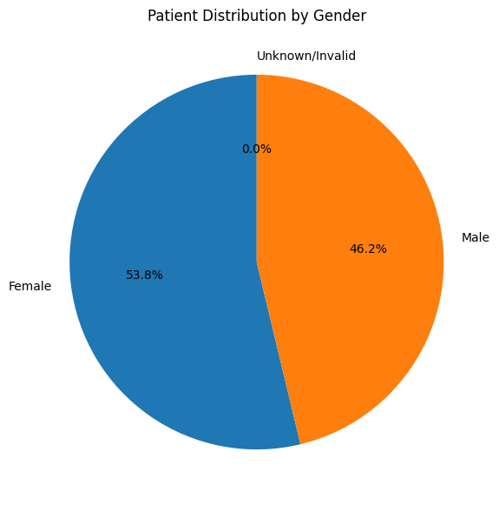

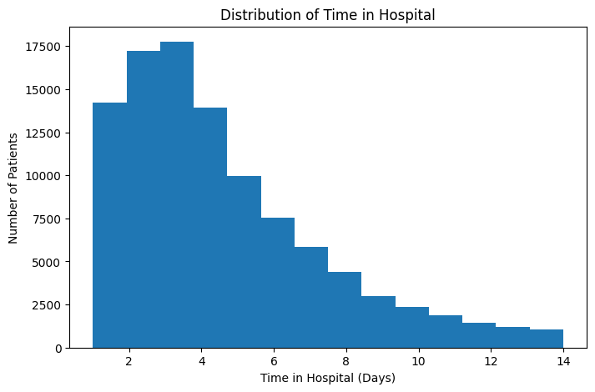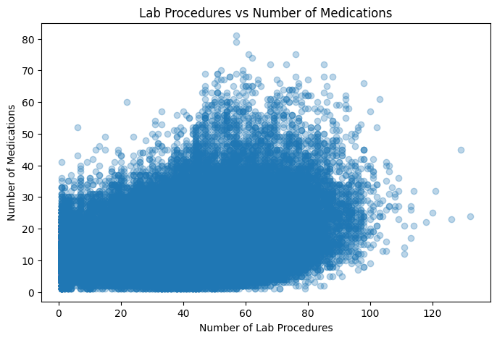

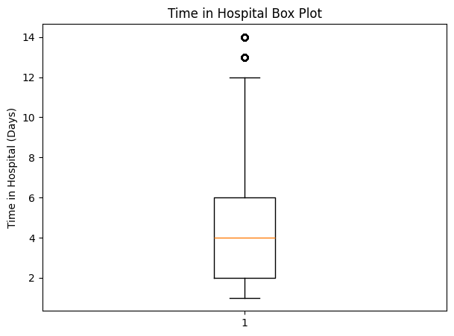

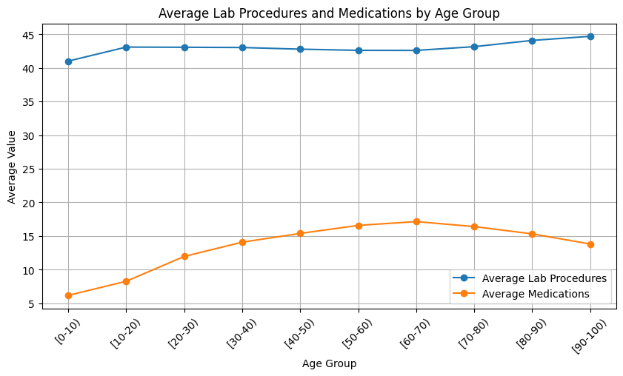
Result:

